**MENTAL HEALTH IN THE TECH FIELD: AN ANALYSIS**

Aathira P *1

*(Student)*

*1MCA, Department of Computer Science, Rajagiri College of Social Sciences, Cochin

**Abstract -** Mental health encompasses emotional, behavioural, and cognitive wellbeing. All that matters is how people behave, feel, and think. The term "mental health" may refer to the absence of mental disorders. Mental health can have an effect on daily life, interpersonal connections, and physical health. However, this connection also works in reverse. Personal circumstances, social ties, and physical ailments can all have an impact on mental illness especially for the people working in IT (Information Technology) industry. The overall purpose of this study is to analyse the mental health of those who work in the IT business while taking a range of aspects into account due to the constant physical and mental stress that these professionals face.

1. **Introduction**

Everyone, regardless of age, gender, socioeconomic status, or ethnicity, is at risk of acquiring a mental health issue. A person's mental health can be influenced by social and economic situations, traumatic childhood experiences, biological variables, and underlying medical issues[2]. Many people who suffer from a mental illness have many conditions at the same time. It is critical to understand that good mental health is dependent on a delicate balance of circumstances, and that various causes may contribute to the development of these diseases. Technology-based approaches to mental health rehabilitation are gaining popularity[6]. Nonetheless, despite statistics demonstrating that people with mental illnesses have extensive access to technology, a willingness to use it to improve mental health, and the efficacy of technology-based treatments established by academics, such tools have been underutilised.

In this case study, I provide an overview of the mental health analysis in the technology sector. The goal is to develop a model that can predict whether an employee will seek mental health therapy or not and, in essence, to pinpoint the main characteristics that, depending on a number of variables, cause mental health issues in the IT industry[17].

1. **Background Study**

The tech industry has long been criticised for placing a strain on its employees' mental health. Burnout is all too common in the industry, and the pandemic has only exacerbated problems like isolation and lack of work-life balance. According to the 2021 OSMI Mental Health in IT Survey, more than 90% of professionals in the tech sector have been diagnosed with a mental health disorder[11,18]. A mental health issue has hampered the productivity of around 64.7% of respondents. When discussing mental health, the digital industry adds another layer of complication. The IT industry encourages a 'crunch' culture in which difficult tasks must be accomplished in a short period of time. The industry is recognised for its high stress: late nights, odd hours, and so on[5].

This analysis helps provide a comprehensive view of other factors that contribute to the effect of mental health.

1. **Implementation**

In my case study, I used Kaggle's dataset on the same topic. According to a study published in the Journal of Occupational and Environmental Medicine, roughly 86% of employees report increased work performance and lower absenteeism after receiving depression treatment. Employers will benefit greatly from increased retention and productivity. By giving employees access to mental health insurance, the tech business may begin to foster a culture of understanding and compassion. And having employees who feel cared for and pleased is not just good, but also profitable[12]. Companies can utilise this model to learn more about employee mental health concerns and provide benefits to those who need them, allowing them to make better use of their resources. This model helps avoid the additional costs of providing mental health benefits to individuals who are not asking or using that money for other benefits of that employee., ultimately leading to improved employee satisfaction and overall employee retention.

A full implementation of my analysis can be found at the link below.

* Python Code - <https://github.com/AathiraPrabha/DataMining_Research>
* We can see that there are 26 columns where age is numerical, while the rest are all categorical.
* The time stamp field is meaningless; it indicates the moment when a person filled out the survey form.
  1. **Data Pre-processing**

The Comments column contains over 87% null data. It is understandable because it is not a required question in the survey. This column can be safely removed. We must evaluate how to treat the columns Work interfere and self-employed.

More than 75% of the population is from the United States. Because very few people from different nations participated in the study, it is generally inaccurate to imply that people from a certain region suffer more. As a result, we will remove this column. All the states are from US, so we can drop this column too. We also need to clean gender column as it is having too many different categories. Almost all columns are categorical with 2 & 3 classes. From the gender column, we can say that males are dominant in number than female & other. It should be kept in mind that this doesn't imply that men are vulnerable to mental health problems. The dataset is now pre-processed.

* 1. **Data Analysis**

Each column in the dataset represents a analysis question. Let's have a look at some intriguing questions.

### Have you sought treatment for a mental health condition?

plt.figure(figsize=(8,8))

px.histogram(health, x = 'treatment',color='treatment')

### 

### Nearly 50% of people want help. This is a very large percentage. Studies have shown that mental illness is a major risk factor for suicide. Therefore, we must ensure that insights for model building are available to all who ask for help. This is our target variable. No resampling required as there is no class imbalance.

### What is your age?

px.histogram(health, x = 'age' , color = 'treatment' )

### 

### Surprisingly, children under the age of 12 also participated in the survey. Assume these are incorrect entries and remove them in the insight pre-processing step of model building. Clearly, both distributions are merged. This is not very useful for class prediction.

### Are you self-employed?

px.histogram(health, x = 'self_employed',color='treatment',barmode='group')

### 

### Around 10% of people work for themselves. Despite the enormous differences, the percentage of people seeking treatment is the same in both categories. Thus, whether a person is self-employed or not has no bearing on whether or not they seek treatment. Although the categories are imbalanced, the class distributions for each category are similar. So, this may not affect the model.

### If you have a mental health condition, do you feel that it interferes with your work?

sns.countplot(data = health , x = 'work_interfere')

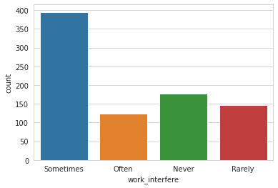

px.histogram(health, x = 'work_interfere',color='treatment',barmode='group’)

### 

### Approximately 78% of respondents reported interference at work, with a ratio of rarely, occasionally, and frequently. Mental health issues can sometimes become an impediment when working about 45% of the time. The plots show that about 80% of people desire to be treated. However, even if mental health has never interfered with work, there is a small group of people who want to obtain therapy before it becomes a job stressor. It can be triggered when the job requirements do not meet the worker's capabilities, resources, or needs. If you manage a tech company, you should consider providing services for employees seeking therapy. This will assist to improve employee experience and will undoubtedly raise productivity.

### Do you have a family history of mental illness?

px.histogram(health, x = 'family_history',color='treatment',barmode='group’)

### 

### People with a mental disorder in their family are more likely to seek therapy. Around 35% of persons who have no family history are also seeking assistance. Model-building insight. People having a family history are more likely to seek treatment than those who do not have a family history. Family history will be an important feature.

### Do you work remotely (outside of an office) at least 50% of the time?

sns.countplot(data = health , x = 'remote_work')

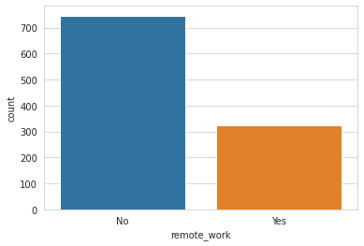

px.histogram(health, x = 'remote_work',color='treatment',barmode='group')

### 

### Whether they work remotely or not, about half of both groups seek treatment. People who work in rural areas are slightly more likely to seek treatment. It could be because of a lack of social connection in distant mode.

### Does your employer provide mental health benefits?

sns.countplot(data = health , x = 'benefits')

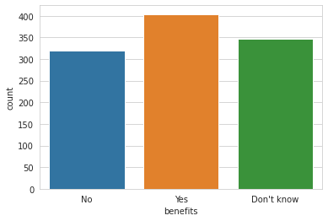

px.histogram(health, x = 'benefits',color='treatment',barmode='group')

### 

### We can observe that approximately 38% of respondents claimed that their employer supplied them with mental health benefits, whereas a substantial number (32%) did not know whether they were provided with this benefit. In the second graph, we can see that 63% of those who replied YES to mental health benefits also claimed they were getting medical care. As a result, we can observe that the employer's resources are being used to a greater level. Even if you consider the cost, you should surely opt for it because the staff make good use of it. Surprisingly, close to 45% of those who answered NO to the company's mental health perks desire to seek mental health care.

### Do you know the options for mental health care your employer provides?

sns.countplot(data = health , x = 'care_options')

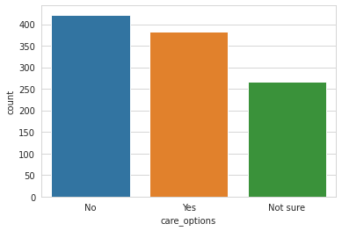

px.histogram(health, x = 'care_options',color='treatment',barmode='group')

### 

### 40% of employees are not given with care options, and 25% are unsure whether care options are available at all. We can observe that 60% of employees whose employers do not provide health care are seeking therapy. These organisations must address this problem. People with care options are seeking therapy, which supports our assertion that we have care alternatives.

### Has your employer ever discussed mental health as part of an employee wellness program?

sns.countplot(data = health , x = 'wellness_program')

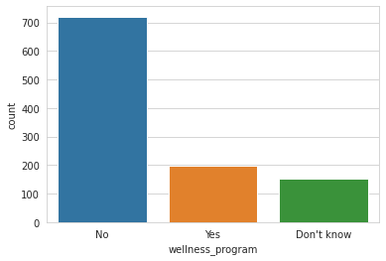

px.histogram(health, x = 'wellness_program',color='treatment',barmode='group')

### 

### The majority of respondents' companies have not discussed mental health as part of an employee wellness programme. Around half of those who are unaware of the programme are looking for assistance. This means that businesses should explain the mental health benefits they offer. Employee wellness programmes should incorporate mental health. This is not to be neglected.

### Does your employer provide resources to learn more about mental health issues and how to seek help?

sns.countplot(data = health , x = 'seek_help')

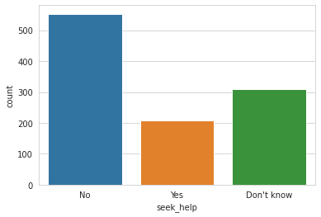

### Most companies do not provide resources or may not provide information about the resources they have This is a useful insight for HR departments to review resource allocations and utilization of existing resources.

### Would you be willing to discuss a mental health issue with your co-workers?

sns.countplot(data = health , x = 'coworkers' )

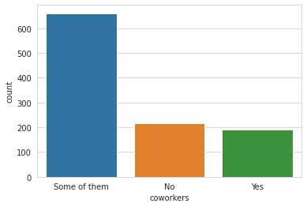

px.histogram(health, x = 'coworkers',color='treatment',barmode='group')

### 

### It is a good sign that most people have at least one person (co-workers) with whom they may discuss their mental health difficulties.

* 1. **Encoding Features**

### We are now defining the target variable as 'treatment,' which predicts whether or not the employee obtains mental illness therapy. Now let’s pre-process the data to make it ready for model building

### We carry out label encoding, splitting, and scaling in order to carry out the prediction.

### 

* 1. **Prediction Algorithms**

For my dataset, I used five different methods to improve the prediction results. The following are the five algorithms used:

1. Logistic Regression
2. Decision Tree Classifier
3. Support Vector Classifier
4. K-Nearest Neighbour Classifier
5. Naïve Bayes Classifier

The outcomes of the aforementioned algorithms are discussed sequentially.

1. **Result and Discussion**

Using Logistic Regression, I was able to acquire an accuracy of 74% along with the F1 scores shown above. Logistic regression is a statistical analysis technique that uses previous observations from a data set to predict a binary outcome, such as yes or no. By examining the correlation between one or more already present independent variables, a logistic regression model forecasts a dependent data variable.

Accuracy when utilising a decision tree was 71%. A non-parametric supervised learning technique for classification and regression is called a decision tree (DT). The objective is to learn straightforward decision rules derived from the data features in order to build a model that predicts the value of a target variable. A piecewise constant approximation of a tree can be thought of.

The Support Vector Machine (SVM) method correctly predicts my dataset 86% of the time. In classification issues, SVM is used. When using the SVM algorithm, each data point is represented as a point in n-dimensional space (where n is the number of features you have), with each feature's value being the value of a certain coordinate. Then, we carry out classification by identifying the hyper-plane that effectively distinguishes the two classes.

The accuracy was 76% using the K-Nearest Neighbour algorithm. One of the simplest machine learning algorithms, KNN is primarily employed for categorization. The data point is categorised based on how its neighbour is categorised.

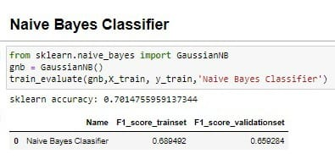

The accuracy achieved with the Naive Bayes Classifier algorithm was 70%. A naive Bayes classifier is a probabilistic machine learning model used for classification tasks. The core of the classifier is based on Bayes' theorem. We can use Bayes' theorem to find the probability that A will occur given that B has occurred. where B is evidence and A is hypothesis. The assumption here is that the predictors/features are independent. The presence of one particular trait does not affect other traits. Therefore, it is called naive.

* 1. **Discussion**

Following is a summary of my analysis's prediction results:

|  |  |  |  |
| --- | --- | --- | --- |
| **Algorithms Used** | **Accuracy** | **F1_Score_Trainset** | **F1_Score_ValidationSet** |
| Support Vector Classifier | 0.86265607264 | 0.859791 | 0.691129 |
| Logistic Regression | 0.74233825198 | 0.738178 | 0.711614 |
| Decision Tree Classifier | 0.7162315550 | 0.699519 | 0.697966 |
| K-Nearest Neighbour Classifier | 0.76730987514 | 0.747226 | 0.600202 |
| Naïve Bayes Classifier | 0.70147559591 | 0.689492 | 0.659284 |

It is evident from the table of results above that, when compared to other methods, the Support Vector Classifier has the highest accuracy. Therefore, I might claim that Support Vector Classifier, which has an accuracy of 86%, is the best algorithm for my dataset.

1. **Conclusion**

Researchers envision how predictive accuracy can help analyst staff analyse past results. In this article, we tried to get the most accurate predictions for the recorded data set. The proposed algorithm may not provide the same accuracy on other datasets, but it turned out to be the best in my case. My case study revealed that the algorithm I used for the model I created provided an accuracy of about 86%. This gives insight that there is high work stress among her IT department employees who employ mental illness and should be significantly reduced.

1. **References**

[1] [Chris Lovejoy](https://www.researchgate.net/profile/Chris-Lovejoy). *Technology and mental health: The role of artificial intelligence.* January 2019 [European Psychiatry](https://www.researchgate.net/journal/European-Psychiatry-1778-3585) 55(August 13):1-3 DOI:[10.1016/j.eurpsy.2018.08.004](http://dx.doi.org/10.1016/j.eurpsy.2018.08.004)

# [2] Ananya, Bathala; Priya, V. Vishnu; Gayathri, R. *Stress and health problems among information technology professionals.* Drug Invention Today . Jul2019, Vol. 12 Issue 7, p1336-1338. 3p. 1 Diagram.

[3] Anthony D. LaMontagne, Tessa Keegel and Deborah Vallance. *Protecting and promoting mental health in the workplace: developing a systems approach to job stress.* Health Promotion Journal of Australia 18(3) 221 – 228. Published: 01 December 2022

[4] Prem Chopra. *Mental health and the workplace: issues for developing countries.* Published: 20 February 2009 International Journal of Mental Health Systems 2009, 3:4 doi:10.1186/1752-4458-3-4

[5] [Jakkula V. Rao](https://pubmed.ncbi.nlm.nih.gov/?term=Rao%20JV%5BAuthor%5D) and [K. Chandraiah](https://pubmed.ncbi.nlm.nih.gov/?term=Chandraiah%20K%5BAuthor%5D). *Occupational stress, mental health and coping among information technology professionals.* [Indian J Occup Environ Med.](https://www.ncbi.nlm.nih.gov/pmc/articles/PMC3482704/) 2012 Jan-Apr; 16(1): 22–26. doi: [10.4103/0019-5278.99686](https://doi.org/10.4103%2F0019-5278.99686)

[6] [Helen Christensen](https://journals.sagepub.com/doi/abs/10.1177/0004867412471088?journalCode=anpa), [Katherine Petrie](https://journals.sagepub.com/doi/abs/10.1177/0004867412471088?journalCode=anpa)*. Information technology as the key to accelerating advances in mental health care.* Published February 4, 2020.

[7] [Nicole DePasquale](https://journals.sagepub.com/doi/abs/10.1177/0192513X15584680), [Courtney A. Polenick](https://journals.sagepub.com/doi/abs/10.1177/0192513X15584680), [Kelly D. Davis](https://journals.sagepub.com/doi/abs/10.1177/0192513X15584680), [Phyllis Moen](https://journals.sagepub.com/doi/abs/10.1177/0192513X15584680), [Leslie B. Hammer](https://journals.sagepub.com/doi/abs/10.1177/0192513X15584680), [David M. Almeida](https://journals.sagepub.com/doi/abs/10.1177/0192513X15584680). *The Psychosocial Implications of Managing Work and Family Caregiving Roles: Gender Differences Among Information Technology Professionals*. [Volume: 38 issue: 11,](https://journals.sagepub.com/toc/jfi/38/11)page(s): 1495-1519. Article first published online: May 5, 2015; Issue published: August 1, 2017

[8] [Tushyati Maudgalya](https://www.tandfonline.com/author/Maudgalya%2C+Tushyati), [Scott Wallace](https://www.tandfonline.com/author/Wallace%2C+Scott), [Nancy Daraiseh](https://www.tandfonline.com/author/Daraiseh%2C+Nancy), [Sam Salem](https://www.tandfonline.com/author/Salem%2C+Sam). *Workplace stress factors and ‘burnout’ among information technology professionals: a systematic review.* Received 13 May 2005, Accepted 15 May 2005, Published online: 02 Nov 2010.

[9] [Marilyn S. Fetter](https://www.tandfonline.com/author/Fetter%2C+Marilyn+S), PMHCNS-BC. *Improving Information Technology Competencies: Implications for Psychiatric Mental Health Nursing.* Published online: 09 Jul 2009

[10] [Riba Maria Kurian](https://www.tandfonline.com/author/Kurian%2C+Riba+Maria) & [Shinto Thomas](https://www.tandfonline.com/author/Thomas%2C+Shinto). *Perceived stress among information technology professionals in India during the COVID-19 pandemic*. Received 27 Nov 2020, accepted 07 Mar 2021, Published online: 31 Mar 2021

[11] [V. Padma](https://pubmed.ncbi.nlm.nih.gov/?term=Padma%20V%5BAuthor%5D), [N. N. Anand](https://pubmed.ncbi.nlm.nih.gov/?term=Anand%20NN%5BAuthor%5D), [S. M. G. Swaminatha Gurukul](https://pubmed.ncbi.nlm.nih.gov/?term=Gurukul%20SM%5BAuthor%5D), [S. M. A. Syed Mohammed Javid](https://pubmed.ncbi.nlm.nih.gov/?term=Javid%20SM%5BAuthor%5D), [Arun Prasad](https://pubmed.ncbi.nlm.nih.gov/?term=Prasad%20A%5BAuthor%5D), and [S. Arun](https://pubmed.ncbi.nlm.nih.gov/?term=Arun%20S%5BAuthor%5D). *Health problems and stress in Information Technology and Business Process Outsourcing employees*. [J Pharm Bioallied Sci.](https://www.ncbi.nlm.nih.gov/pmc/articles/PMC4439723/) 2015 Apr; 7(Suppl 1): S9–S13. doi: [10.4103/0975-7406.155764](https://doi.org/10.4103%2F0975-7406.155764)

# [12] [Jessica E.HabererM.D., M.S.a](https://www.sciencedirect.com/science/article/abs/pii/S0163834313000704" \l "!)[TomTrabinPh.D., M.S.M.b](https://www.sciencedirect.com/science/article/abs/pii/S0163834313000704" \l "!)[MichaelKlinkmanM.D., M.S.](https://www.sciencedirect.com/science/article/abs/pii/S0163834313000704" \l "!) *Furthering the reliable and valid measurement of mental health screening, diagnoses, treatment and outcomes through health information technology*. Received 20 March 2013, Accepted 20 March 2013, Available online 28 April 2013.

[13] [Sandra Benavides-Vaello MPAff, PhD, RN](https://link.springer.com/article/10.1007/s11414-012-9299-6#auth-Sandra-Benavides_Vaello),  [Anne Strode MSW](https://link.springer.com/article/10.1007/s11414-012-9299-6#auth-Anne-Strode) &  [Beth C. Sheeran BSN, RN](https://link.springer.com/article/10.1007/s11414-012-9299-6#auth-Beth_C_-Sheeran). *Using Technology in the Delivery of Mental Health and Substance Abuse Treatment in Rural Communities: A Review.* [The Journal of Behavioral Health Services & Research](https://link.springer.com/journal/11414) volume 40, [Published: 24 October 2012](https://link.springer.com/article/10.1007/s11414-012-9299-6#article-info)

[14] [Kathryn R. Puskar](https://www.tandfonline.com/author/Puskar%2C+Kathryn+R), [Jill Aubrecht](https://www.tandfonline.com/author/Aubrecht%2C+Jill), [Kathleen Beamer](https://www.tandfonline.com/author/Beamer%2C+Kathleen) & [Lisa J. Carozza](https://www.tandfonline.com/author/Carozza%2C+Lisa+J). *Implementing Information Technology in a Behavioral Health Setting*. Published online: 09 Jul 2009.  <https://doi.org/10.1080/01612840490443428>

[15] Adrian Aguilera. *DIGITAL TECHNOLOGY AND MENTAL HEALTH INTERVENTIONS: OPPORTUNITIES AND CHALLENGES*. Received: January 16, 2014. Accepted: July 25, 2014. Copyright: © 2015 CSIC. This is an open-access article distributed under the terms of the Creative Commons Attribution-Non-Commercial (by-nc) Spain 3.0 License.

[16] [Kevin Schartz Ph.D., M.C.S.](https://onlinelibrary.wiley.com/action/doSearch?ContribAuthorRaw=Schartz%2C+Kevin),[Helen A. Schartz Ph.D., J.D.](https://onlinelibrary.wiley.com/action/doSearch?ContribAuthorRaw=Schartz%2C+Helen+A),[Peter Blanck Ph.D., J.D.](https://onlinelibrary.wiley.com/action/doSearch?ContribAuthorRaw=Blanck%2C+Peter) *Employment of persons with disabilities in information technology jobs: literature review for “IT works”.* 02 December 2002. <https://doi.org/10.1002/bsl.510>. Citations: [20](https://onlinelibrary.wiley.com/doi/abs/10.1002/bsl.510#citedby-section)

# [17] [Alexis Quesada-Arencibia](https://journals.sagepub.com/action/doSearch?target=default&ContribAuthorStored=Quesada-Arencibia%2C+Alexis), [Enrique Pérez-Brito](https://journals.sagepub.com/doi/full/10.1177/1460458216669555), [Carmelo R García-Rodríguez](https://journals.sagepub.com/doi/full/10.1177/1460458216669555), [Ana Pérez-Brito](https://journals.sagepub.com/doi/full/10.1177/1460458216669555). *An eHealth information technology platform to help the treatment of mental disorders.* First Published September 30, 2020.

[18] Karad CA – B.D. *Job Stress in Information Technology Sector – the Cause and Effect Analysis*. Journal of Commerce & Management Thought. Year : 2010, Volume : 1, Issue : 3.